Cody Costa

EE263

8/4/2025 resubmission

Homework 2

**PYTHON IMAGE RESULTS:**

Please see attached code files to assignment submission for step-by-step procedure

PROBLEM 1)

Input Images: Clean Lena image

Salt+Pepper and Gaussian noise Lena (used for filtering)

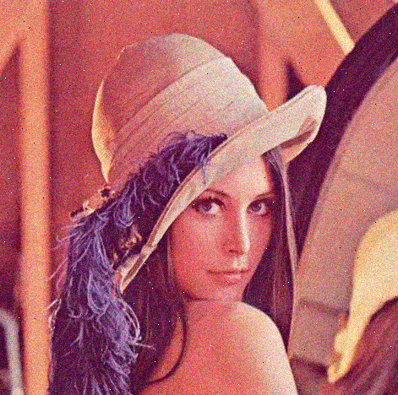

Output images:

Median Filter

Smoothing Filter

Combined Filter

IN THIS CASE, THE MEDIAN FILTER GIVES THE SHARPEST IMAGE OF THE 3 FILTERS

PROBLEM 2)

Input Image: Lena with random noise

Output Image: Smoothed, filtered image

PROBLEM 3)

Input Image:

Output Images:

Bilateral Filter (left) Nagao Matsuyama filter (right)

PROBLEM 4)

Input Image:

Output Images:

Standard Bilateral Filter

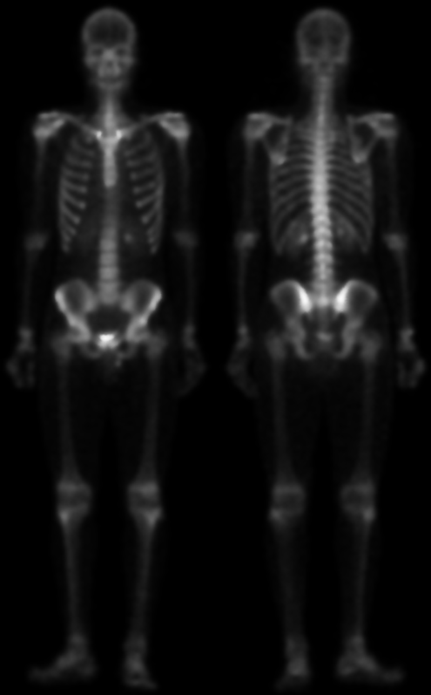

G(D) / I computation

G(D) / I^2 computation

IN THIS CASE, THE CUSTOM VECTORIZED BILATERAL FILTERS PRESERVE EDGES BETTER THAN THE REGULAR FILTER DOES

PROBLEM 5)

Computations on sample section of LENA image are as follows:

